Booking Form for UNIVERSITE DE TOULOUSE Seminar
Please complete the booking form and return it before 28/04/2026

Last name: First name: Company:

Address:

E-Mail: Phone number:

Your booking

Arrival date: Departure date:

Room type:
☐Single room

☐ Double room

☐ Twin room

Number of rooms:

Rates

Rate room (per night, breakfast included): € 175 for a single room & € 195 for a twin room
City tax: € 3.60 per person and per night
Price valid for the nights from the 17th of May (included) to the 20th of May only (included)

Booking Policy:

Sales conditions

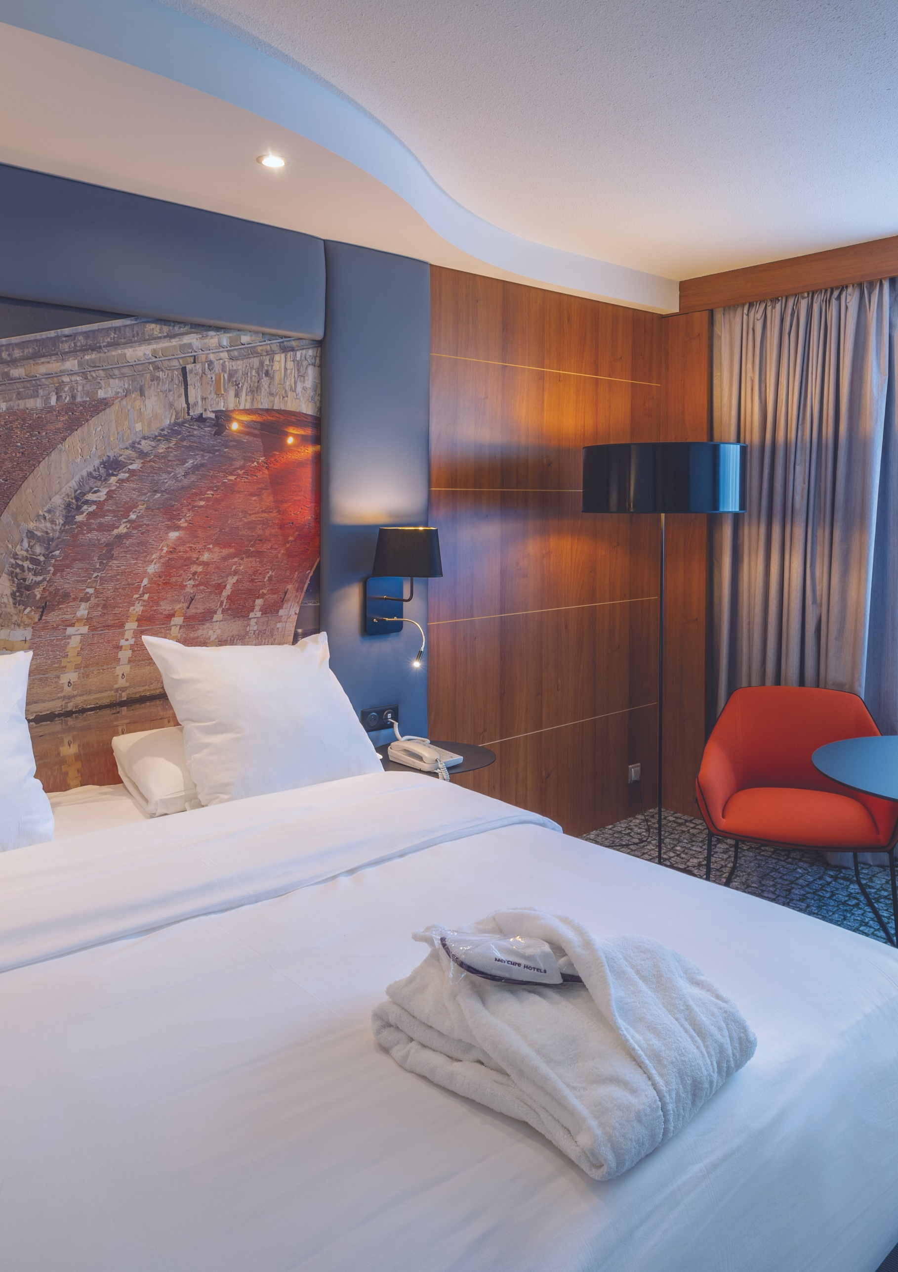

- No booking will be registered without credit card information.
- The entire stay will be debited 30 days before arrival.
- The Hotel will reconfirm the participant booking within 3 days.
- After the booking deadline above indicated, bookings will be registered according to availabilities and with the rate of the day.
Cancellation policy:
- For any cancellation made 30 days before the check in, there will be no cancellation fees.
- For any cancellation made later than 29 days, the hotel will charge you the total amount of the reservation.
- In case of no show, the whole stay will be charged on your credit card.

Payment details

Card number:

Name of Cardholder: Expiry date:

Card type: ☐ Visa ☐ Mastercard ☐ American Express

I, the undersigned authorise the hotel to debit my credit card

as per the above details.

Mercure Toulouse Centre Compans - 8 Esplanade Compans Caffarelli - 31000 TOULOUSE Tél. +33 5 61 11 09 09 – E-mail : H1585@accor.com

